Dalton Murray

Systems Analysis and Design

INT 4202 - 1952-202310_INT4203_M

Dr. Anthony Padalino

October 4, 2022

**Week 5 Assignment**

**Describe a data dictionary and list the types of information it contains.**

A data dictionary is often referred to as a data repository and is what analysts use to store information about anything such as database information like its format, structure, descriptions of content, relationships between elements, and other metadata (Tilley, S. p. 164). On top of this, data dictionaries are a “central storehouse of information” and is used to collect as well as document and even organize in any way that the analysts want about the system (Tilley, S. p. 164). In other words, a data dictionary is what is used to store helpful information which relates to other data, such as metadata. It does this by defining and describing every data element, which is called a data item or field, and is the smallest possible piece of information or data which has any form of meaning regarding an information system (Tilley, S. p. 164). This data element could be things such as student grades, inventory quantities or costs, salaries, social securities, and even just the organization’s name (Tilley, S. p. 164). From data elements you can make something called a data record or a data structure which are combinations of data elements which relate to each other (Tilley, S. p. 164). These are also the types of information data dictionaries may store, as they’re just the smallest data that has a meaning behind it, in other words essentially anything as an individual thing which then combines and makes more things or more data or information like part numbers, costs, data element names, aliases if there are any, type and lengths of the data, its default values, acceptable values for the data, the source of it, its security, responsible users for it, and descriptions or comments (Tilley, S. p. 164-165). Data dictionaries may also consist of data flows, data stores, processes, entities, records, and other useful information (Tilley, S. p. 164-165). Data dictionaries may also use CASE tools which helps ensure data consistency (Tilley, S. p. 164).

**Why would a manager prefer a decision tree instead of a decision table?**

A manager may prefer to make a decision tree instead of a decision table as it is often referred to as being a more graphical representation of conditions, actions, and rules than the decision table (Tilley, S. p. 175). It also may take less time going through the decision tree than trying to read an entire decision table in order to figure out what the process is and what the result is. A decision tree shows the logical structure behind a decision in more detail than a decision table and may flow more easily when trying to make a decision than going through a whole decision table to find what you need to do to make a decision (Tilley, S. p. 175). A decision tree does show the same results as a decision table; however, it shows it in a different form which may be easier and faster to get to the results as well as communicate more easily to many different people (Tilley, S. p. 175). This means that a decision tree may be considered easier to read than a decision table and may be less complex than one, however, it does matter on personal preference (Tilley, S. p. 175).

Below you can see, the first image a decision table and the second a decision tree. The second one explains the process in a more simple way than the first one, following the branches of what you have to come to the end result whereas the first one you have to read and comprehend the table to find what decision you need to make.

(Tilley, S. p. 174).

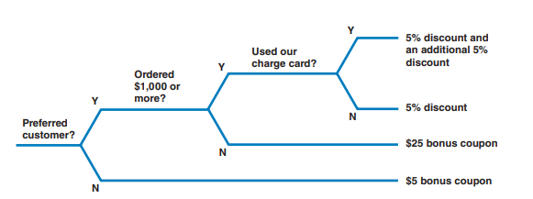

(Tilley, S. p. 175).

References

Tilley, S. (2020). Systems analysis and design (12th ed.). Cengage.

I have neither given nor received unauthorized aid in completing this work, nor have I presented someone else's work as my own.

*Dalton Murray*